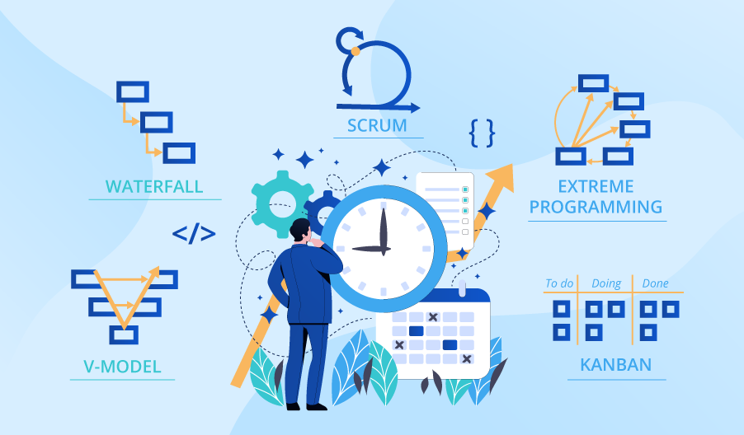

**SE423**

**Software Project Management**

**Activity**

**Activity 2. Project-Based and Product-Based Software Engineering.**

1. Have a discussion with 3-4 of your classmates about the differences between project-based and product-based software engineering. Come to an agreement on what you think are the three main differences and write them down.
2. Consider a company that builds payroll software for small businesses as a product line. Discuss with your teammates how a project to build a new payroll system for a customer could leverage the existing product line. Some possibilities include:

* Reusing core components like the tax calculation engine, reporting modules, etc.
* Tailoring the product for the specific customer based on variable features like number of employees, payment schedules, etc.
* Combining reusable components with some newly developed features to meet the customer's unique needs.

Discuss how the product line architecture could accommodate projects like this example payroll system project. Share your key discussion points with the class.

Submit your answers to LMS as PDF file.